SDK ApplicationService:
The ApplicationService accepts requests from various interfaces and forwards them to the appropriate persistence tier implementation. The Application Service tier is the main tier that facilitates the operations within the caCORE SDK generated system, and its methods in the ApplicationService interface are exposed to the Java Clients.
The class ApplicationServiceImpl has the concrete implementation of the ApplicationService interface. When any of the client interfaces in the caCORE SDK code requests a handle to the ApplicationService, the default implementation of ApplicationServiceImpl is returned. When the remote Java client requests a handle to the ApplicationService, a remote handle to the ApplicationService is wrapped inside the ApplicationServiceProxy and returned to the client.
In order for the client application to obtain the handle to the service tier (Application Service) of the generated application, caCORE SDK provides a helper class called ApplicationServiceProvider (ASP). ASP instantiates the service based on the settings in the configuration file (application-config.xml).
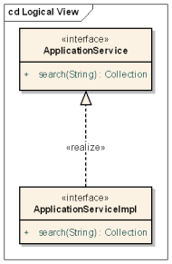
Following is the default configuration for ApplicationService in application-config.xml
<bean id="ApplicationService" class="org.springframework.aop.framework.ProxyFactoryBean" singleton="false">
<property name="target" ref="ApplicationServiceImpl" />
<property name="interfaces" value="gov.nih.nci.system.applicationservice.ApplicationService" />
<property name="interceptorNames">
<list>
<idref local="TxInterceptor" />
<!--<idref local="CLMInterceptor" />-->
</list>
</property>
</bean>

<bean name="ApplicationServiceImpl" class="gov.nih.nci.system.applicationservice.impl.ApplicationServiceImpl" singleton="true">
<constructor-arg ref="ClassCache" index="0"></constructor-arg>
</bean>

Following diagram represents sequence of steps to query SDK generated system by a client application. SDK generated system represent a data service that provides standardized consistent APIs to query data from a data source (database). SDK generated service connects to one data source at any time.
The ApplicationServiceProvider is a helper class to create ApplicationServiceImpl instance. AThe pplicationServiceProvider does not cache or has any internal static reference of the ApplicationService. When a client request getApplicationService() operation, ASP requests Spring Framework to get an instance of the ApplicationService.
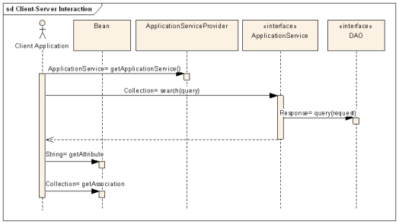

Given the background on ApplicationService, let us look at the scenarios in discussion.
Scenario 1:
The ApplicationService class represents a connection to a service at a given URL. That means that you can only connect to one URL at a time. In using the APIs for integration where you would want to work with the APIs to more than one application at a time - or different instances of the same application at different locations.

Analysis:
The ApplicationService represents a connection to SDK generated application to query data. The ApplicationService is a façade with convenient operations to query data from a connected data source. SDK application provides four different client interfaces to reach the application service tier.
- XML-JSON-HTTP interface
- Web service client
- Local Java API client
- Remote Java API client

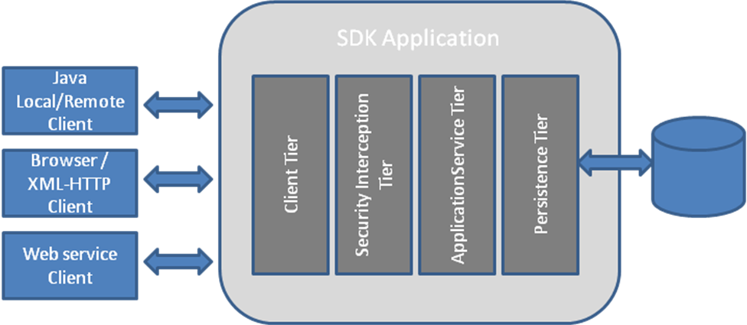
SDK depends on the Spring Framework to initialize and instantiate beans and make them available at runtime. The ApplicationService bean life cycle varies based on the access to SDK generated application. When local Java API client is used, a new instance of ApplicationService will be created for each request. For all other types of client requests, Spring container initialize and instantiate the ApplicationService bean during startup and return cached instance for each request.
The ApplicationService is a stateless bean that acts as façade to the incoming requests and forward them persistence tier to query data. In view of remote Java API client, one cached ApplicationService bean will be serving requests from multiple remote clients in an unsynchronized manner. This singleton behavior can be changed by updating ApplicationService configuration. When “singleton=false” is set, each remote request would be served by a new instance of ApplicationService bean.
<bean name="ApplicationServiceImpl" class="gov.nih.nci.system.applicationservice.impl.ApplicationServiceImpl" singleton="false">
<constructor-arg ref="ClassCache" index="0"></constructor-arg>
</bean>

Multiple SDK generated applications can be deployed into a single container. In this case, each application will be deployed with its own context and ApplicationService instance.
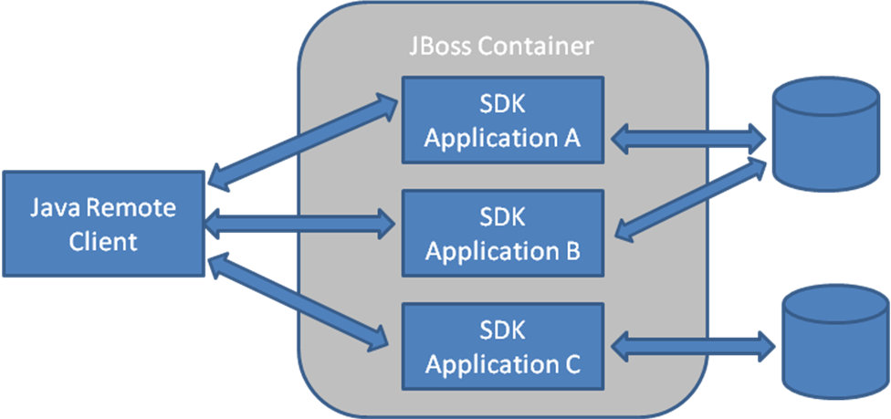

SDK client application framework can be used to connect to multiple application services at the same time; that is, the client can connect to various caCORE SDK generated services at the same time using the same framework.
In order to facilitate multiple service connections, the ApplicationServiceProvider (ASP) class can be used. ASP reads information from the file application-config.xml to create a new instance of the Application Service. If the client application does not mention the service it needs to connect to, the ASP initializes the service described under the "ServiceInfo" bean in the configuration file. However, if the client application mentions the name of the service, the ASP locates the configuration entry for that service, instantiates the service handler, and returns it to the client.
ApplicationService appService1 = ApplicationServiceProvider.getApplicationServiceFromUrl("http://localhost:19280/Person", "PersonServiceInfo");
ApplicationService appService2 = ApplicationServiceProvider.getApplicationServiceFromUrl("http://localhost:19280/Protocol", "ProtocolServiceInfo");

One SDK application can also be deployed into multiple containers as shown in the diagram below. In this case, a remote client can connect to these instances as follows to query data.
ApplicationService appService1 = ApplicationServiceProvider.getApplicationServiceFromUrl("http://host1:19280/Person", "PersonServiceInfo");
ApplicationService appService2 = ApplicationServiceProvider.getApplicationServiceFromUrl("http://host2:19380/Person", " PersonServiceInfo ");

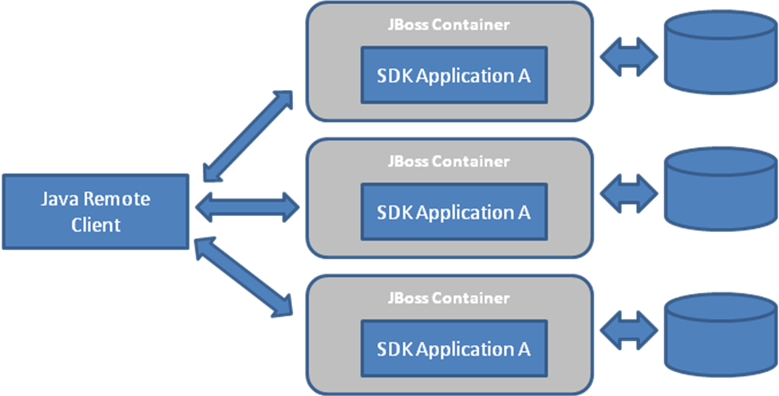
Scenario 2:
The grid service uses the API. We have different APIs for each set of dynamic extensions. To deploy these as grid services means we have to have a different Jboss instance for each.

Analysis:
A caGrid data service developed with Introduce and deployed into caGrid enabled container would be deployed into wsrf.war. All application jars are placed in wsrf.war/lib folder. Same wsrf.war is shared for multiple grid data services deployed in the same container. This could cause naming conflicts with multiple jars.

SDK generated application consists of following artifacts along with other application jars.
< applicationname >-beans.jar
< applicationname >-orm.jar
< applicationname >-schema.jar
<applicationname>-config.jar

<applicationname>-config.jar consists of configuration files and these file names are same across application generated by SDK. Same with <applicationname>-orm.jar. File names in *-beans.jar, *-orm.jar and *-schema.jar may differ based on application model.

Each SDK generated application would require a hibernate session to connect to the database. Due to single wsrf.war deployment, there can be only one active hibernate session. In a multiple grid data service deployment, first loaded configuration would win and rest of the configurations is ignored.

Conclusion:
The ApplicationService is a façade that redirects incoming request to appropriate DAO implementation to query data. The ApplicationServiceProvider is a helper class to create ApplicationService instance. The ApplicationService can also be created directly without using ApplicationServiceProvider that would bypass security checks.

Behavior of ApplicationService is as follows with these different scenarios:

Local client:
With default settings, each local client request will create a new instance of ApplicationService bean.

Remote client:
With default settings, each remote client request will be served by a cached instance of ApplicationService bean. The cached instance is created during startup of the container. This behavior can be changed by updating ApplicationServiceImpl configuration to create a new instance for each request.

- Same instance of SDK application in multiple containers:
A remote client can connect to multiple containers hosting same application through ApplicationServiceProvider.getApplicationServiceFromUrl(URL, ServiceContext)

- Multiple SDK applications in a single container:
A remote client can connect to a container hosting multiple SDK generated applications through ApplicationServiceProvider.getApplicationServiceFromUrl(URL, ServiceContext)

Each SDK generated web application deployed into JBoss container would create an instance of the ApplicationService. These services can be referred through application context URL and serviceinfo name. This way, one remote client can access multiple SDK generated applications simultaneously.

In case of a caGrid data service, it is deployed into the Globus container. This service is deployed into the web application called “wsrf.war”. This web application is a common placeholder for all services deployed into the container. When a data service is deployed, it would create a hibernate session to query data. In case of multiple data services deployed, there would be one hibernate session that will not work for all deployed services.

